How to use TextToCSV app

# CONVERT VPN DUMP TO CSV

1. 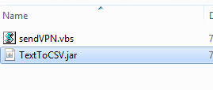Open the application by double clicking the TextToCSV.jar file
2. The Application UI will be launched.

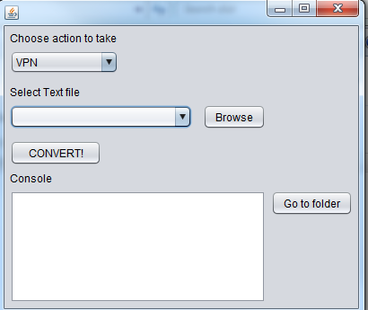

1. Be sure that the **VPN** option is selected on the “Choose action to take” drop down
2. Click **Browse** button and select the VPN dump that you want to transform to a CSV and Click **Open.**

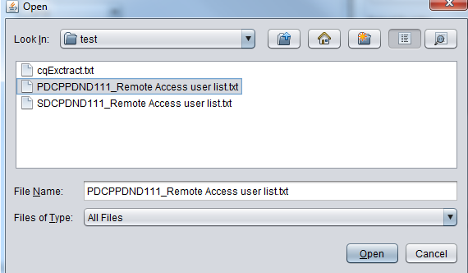

1. Click on the **Convert!** Button. This action will create a CSV file with the information on the VPN dump; in addition, a Successful message will be displayed in the App’s Console.

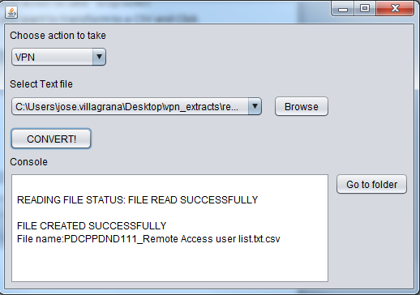

1. To go to the folder where the new CSV file was created, click on the **Go to Folder** button.

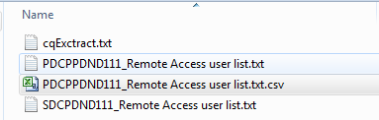

# CONVERT CLEAR QUEST DUMP TO CSV

1. Open the application by double clicking the TextToCSV.jar file
2. The Application UI will be launched.



1. Be sure that the **CLEAR_QUEST** option is selected on the “Choose action to take” drop down
2. Click **Browse** button and select the CLEAR_QUEST dump that you want to transform to a CSV and Click **Open.**

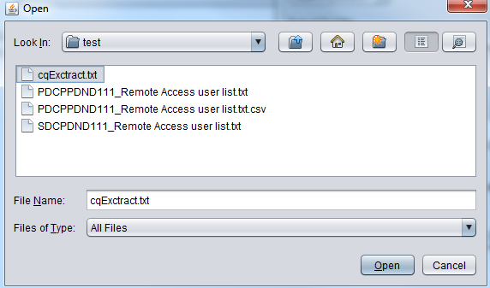

1. Click on the **Convert!** Button. This action will create a CSV file with the information on the CLEAR QUEST dump; in addition, a Successful message will be displayed in the App’s Console.

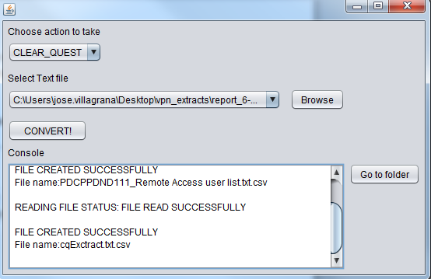

1. To go to the folder where the new CSV file was created, click on the **Go to Folder** button.

